ELEVATION CHANGES
IN THE
CITY OF LONG BEACH

NOVEMBER 2006 THROUGH APRIL 2007

PREPARED

FOR

LONG BEACH CITY COUNCIL

BY THE

LONG BEACH GAS AND OIL

DEPARTMENT

CONTENTS

Page
I. SUBSIDENCE AND REBOUND SURVEY ANALYSIS

Elevation Change – November 2006 through April 2007 …………………… 3

Elevation Change – May 2006 through April 2007………..…………………. 4

Use of Global Positioning System (GPS)……………………………………. 5

II. APPENDIX

Brief History of Long Beach Subsidence .............…………………………. 6

Survey Accuracy ....................................…………………………………… 7

Elevation Change Map Construction ...............……………………………. 8
.
Bench Mark and Net Injection Graphs,
Harbor District ...............................………………………………….. 8

Bench Mark and Net Injection Graphs,
Ocean Boulevard and Offshore Drilling Islands. ..………………….. 9

III. ELEVATION CHANGE MAPS Figures

November 2006 through April 2007 ..............………………………….……. 1

May 2006 through April 2007……..………………………………………..…. 2

BENCH MARK AND NET INJECTION GRAPHS

Bench Mark Location Map ................……………………………….…….... 3
Harbor District, Fault Blocks II-V ................………………………………. 4-7

Coastal Areas and Offshore Drilling
Islands, Fault Blocks VI through 90S .................……….………… 8-13

ELEVATION SURVEY ANALYSIS

The City of Long Beach semi-annual elevation survey of the Civic Center, Central City, Harbor, Alamitos Bay, Naples, and offshore areas was conducted during May 2007. Changes in elevation that have occurred since the last two surveys, November 2006 and May 2006 are discussed in this report. The results in this report reflect elevation changes both within and beyond the scope of oilfield operations. Some changes are due to natural geologic factors.

Elevation Change – November 2006 through April 2007 (Figure 1)

Elevations throughout the Civic Center, Alamitos Bay, and Naples areas were stable during the six-month period. The Central City and Downtown Shoreline experienced a localized elevation decrease of 0.05 to 0.08 feet (0.60 to 0.96 inches) during the period. There is no immediate reason for concern. These minor elevation changes were due to ongoing waterflood adjustments corresponding to a temporary focused oil field development program. Significantly increased and realigned water injection is addressing the issue. Elevations in the City of Long Beach beyond the boundaries of the Wilmington Oil Field were stable. Minor elevation changes in geologically active areas outside the Wilmington Oil Field indicate that this six-month period was an “up” period, semi-regionally.

The Harbor District elevations were stable during the six-month period, except for Pier S. A remnant elevation loss of up to 0.056 feet (0.67 inches) not large enough to map was observed on the northern edge of Pier S adjacent to the Cerritos Channel. This minor elevation decline was due to a focused oil field development program. This area has been stabilized by increased water injection since this survey’s data was collected.

Elevations over the curtailed Tar II streamflood on Pier A West and adjacent Henry Ford Avenue increased up to 0.043 feet (0.52 inches). LBGO implementation of increased water injection and production rates hastened heat withdrawal while maintaining reservoir pressures. This area has been stabilized.

The Oil Islands were stable for the period except for Island Grissom that declined 0.059 feet (0.71 inches). This minor decline was also due to the temporary focused oil field development program. Increased and realigned water injection will address the elevation loss.

Elevation Change – May 2006 through April 2007 (Figure 2)
Elevations throughout the Central City, Alamitos Bay, and Naples areas remained stable during the 12-month period. The Central City and Downtown Shoreline experienced a localized elevation decrease of up to 0.098 feet (1.18 inches). This decrease was due to ongoing waterflood adjustments corresponding to a temporary focused oil field development program. Significantly increased water injection is addressing the issue.

The Harbor District remained stable during the 12-month period except for a slight elevation gain of up to 0.080 feet (.69 inches) occurred on Piers D, E, and H overlying Fault Blocks IV and V. Water injection has been reduced in this area.

Elevation losses continued through the 12-month period on Piers A, S, and T immediately adjacent the Cerritos Channel overlying Fault Blocks II and III. A one-year maximum elevation loss of 0.121 feet (1.45 inches) is attributed to residual Tar II Shale compaction caused by prior steamflood over-heating, POLB localized surface loading, and increased Fault Block III oil production. Water injection has been increased and realigned in the oil reservoirs of concern.

Three of the four of the Oil Islands were stable for the year. The elevation on Island Grissom decreased 0.075 feet (0.90 inches). This minor elevation decrease was caused by the ongoing focused oil field development in the area. Water injection was increased to correct the loss of elevation.

Use of Global Positioning System (GPS)
LBGO operates the Long Beach Deformation Network (LBDN) consisting of thirteen (13) permanent, reference GPS base stations. This report is based solely upon computer processed LBDN benchmark elevation data generated from GPS satellites. GPS elevation measurements have been demonstrated to be reliable and can be more accurate than the spirit leveling which it replaced. The field data collection time has been reduced by more than 65 percent and the 800 spirit leveled bench marks have been reduced to approximately 240 GPS benchmarks.

(Reference: Appendix, Survey Accuracy, pg. 7)
APPENDIX

Brief History of Long Beach Subsidence
Long Beach and the general vicinity have a history of regional subsidence (losses of elevation) since 1929. Elevation changes were minor amounting to an average of about -0.036 feet (-0.43 inches) per year until about 1939. Geologic movement such as the Long Beach Earthquake of March 1933 altered this average rate at times. The reason for this slight regional subsidence or slight elevation loss is not fully understood. Contributing causes appear to be groundwater withdrawal from aquifers in the Long Beach area, regional basin sediment compaction, and tectonic effects.

Development of the Wilmington Oil Field began in 1936. Oil operations accelerated subsidence and created a 29-feet deep subsidence bowl centered in the Wilmington-Long Beach Harbor area near Bench Mark 8772 (Figure 6). Development of the Ranger Zone west of Pine Avenue and its extension seaward in 1947 started the first definitive subsidence in the Central Business District that could be attributed to oil production.

Repressuring operations began in the 1950’s. By 1965, subsidence stopped throughout the Long Beach portion of the Wilmington Oil Field. Some bench marks have actually recovered over one foot in elevation. This is known as rebound. As an example, from 1960 to 1970, Bench Mark No. 1735 near the corner of Ocean Boulevard and Magnolia Avenue recovered approximately one foot of elevation.

In the 1990’s, a large Harbor redevelopment project on Pier A destroyed several bench marks that overlaid the now curtailed steamflood project. Elevation losses in the area were suspected and the destruction of these bench marks made it difficult to monitor any changes. In 1998, after the bench marks were replaced, additional well bore investigations determined that subsurface compaction of the deep shale intervals was occurring above the steam flooded zones due to high temperatures. The Fault Block II Tar Zone Steamflood was terminated in 1999, and cold-water injection was initiated. The forced cooling of the deep formations has remedied the subsidence problem.

The Alamitos Bay and Naples area had losses in elevation prior to development of the adjacent oil operations. These original small losses were most likely due to the regional affects of basin sediment compaction and tectonic movements along the Newport-Inglewood Fault Zone. Later, the coastal strip from the Civic Center eastward to the Alamitos Bay Peninsula lost elevation due to oil and gas production from the West Wilmington Oil Field and possibly the adjacent oil fields. The coastal strip rebounded slightly due to water injection from the offshore Oil Islands that began in 1965.

Survey Accuracy
The May 2002 Elevation Leveling Campaign marked the conversion from spirit, first and second order rod leveling, to GPS measurement of City and Harbor bench mark elevations. Through the GPS contractor, Pinnacle Technologies, Inc., a network of thirteen permanent real-time GPS base stations and a central data collection and processing center were installed within the City of Long Beach. Several existing non-City operated stations were integrated into the new network. The Public Works Department’s Bureau of Engineering surveyors utilize mobile GPS equipment linked to the base stations to measure approximately 240 City and Harbor bench marks, down from the previous 800 bench marks.

Through statistical analysis of satellite, base station, and mobile instrument geometries, and a coincident spirit leveling and GPS bench mark elevation survey, City surveyors and Pinnacle estimate the accuracy of GPS elevations to be 6 - 8 millimeters (0.02 feet or 0.24 inches) that is equal to or better than the prior spirit leveling. Areas are considered to be stable where elevation change is less than 0.02 feet (0.24 inches).

Studies by the City’s subsidence control engineers, geologists, and consultants show that the bench marks may at times rise and fall somewhat rhythmically city-wide in such a manner as to make an entire survey either optimistic or pessimistic. These elevation changes are random and not well understood. Repressuring operations and the resulting rebound can mask the rise or fall pattern. Surface elevations in a rebounded area can be expected to fluctuate under changing water flood conditions. Because of these fluctuations, conclusions based upon short-term survey data should be viewed with caution. Short-term survey data are useful for possible early detection and confirmation of subsidence trends or relative elevation changes but should not be accepted without consideration of the above factors. Annual survey data tend to average these fluctuations and depict a more dependable picture of the relative movements of bench marks.

Elevation Change Map Construction (Figure 1 and 2)
All data are presented as contour lines showing the average change in surface elevation during a particular time period. For example, any point along a line reading 0.05 feet (0.60 inches) on an Elevation Change Map gained an elevation of one-twentieth of a foot or six-tenths of an inch during that period. The small hachures along contour lines point towards a loss in elevation.

Bench Mark Location Map (Figure 3)
This map shows the location of bench marks used for the Bench Mark and Net Injection Graphs.

Bench Mark and Net Injection Graphs, Harbor District (Figures 4 - 7)
The benchmarks are normalized to mean sea level. Bench marks are plotted each time they are surveyed and are shown on a graph with a history of net injection for that same area and time. The net injection is the amount of water injected into the reservoirs that underlie that particular bench mark minus the gross fluid produced from the reservoirs in barrels per day. The graphs cover the last 20 years of net injection and bench mark monitoring.

In general, these graphs show a good correlation between the net injection and elevation change. For example, an increase in net injection is usually followed by an increase in elevation. There tends to be a lag time of months and sometimes years between the net injection change and the subsequent elevation change. The elevation plots of benchmarks on Figures 4 through 7 in the Harbor District illustrate surface elevation fluctuations that can be expected to occur under the dynamic reservoir conditions experienced in extremely mature waterflooding operations.

Bench Mark and Net Injection Graphs, Ocean Boulevard and the Offshore Drilling Islands (Figures 8 – 13)
The last 20 years of elevation changes and accompanying net injection histories are shown on Figures 8 through 13 for bench marks located along Ocean Boulevard and on the offshore drilling islands. The elevation changes at Ocean Boulevard near Magnolia Avenue are shown by the graph of Bench Mark 1735 and Bench Mark 1215 on Figure 8. Permanent GPS Station WELL on Figure 12 shows surface elevation changes on the Alamitos Bay Peninsula. Bench Mark 938 monitors elevation changes on Naples Island.
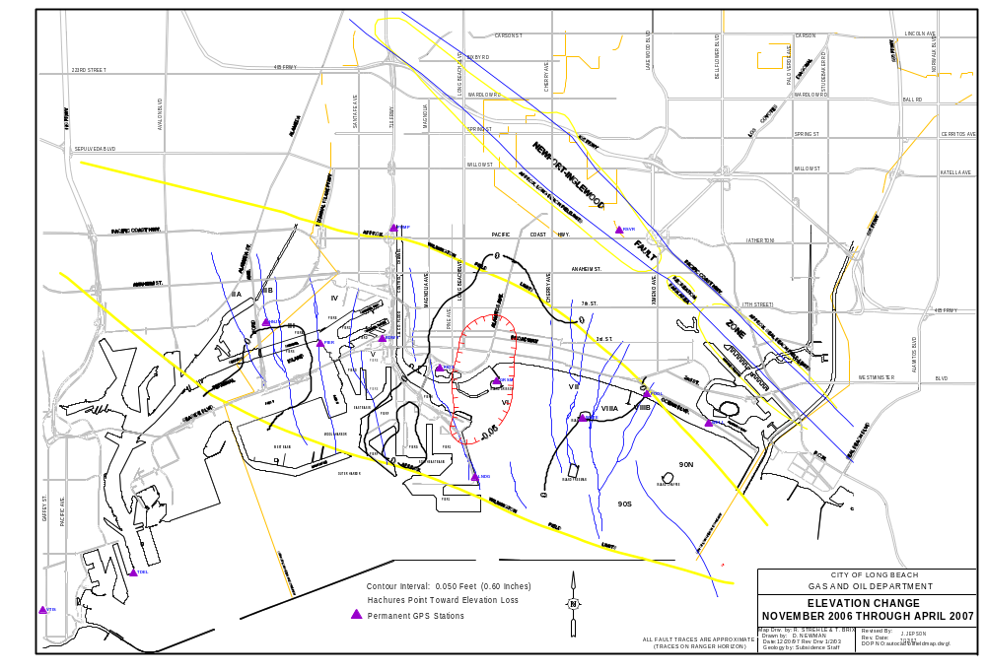
Figure 1

Figure 1
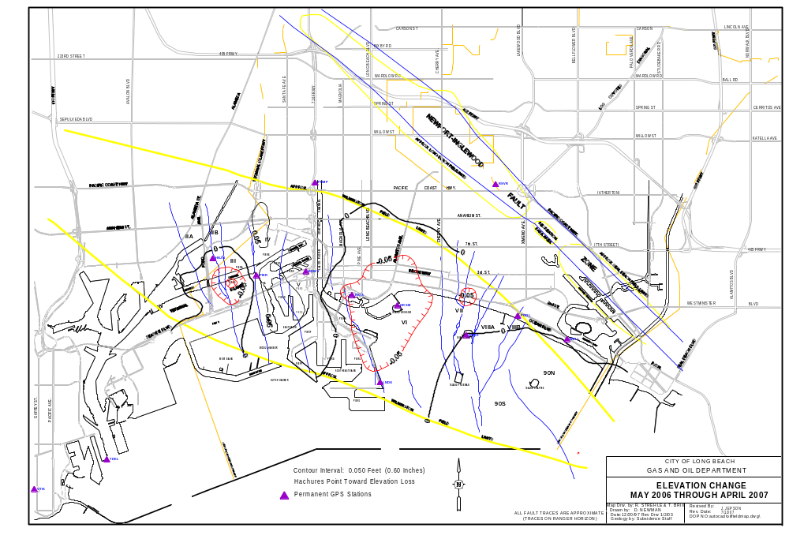

Figure 2

Figure 2

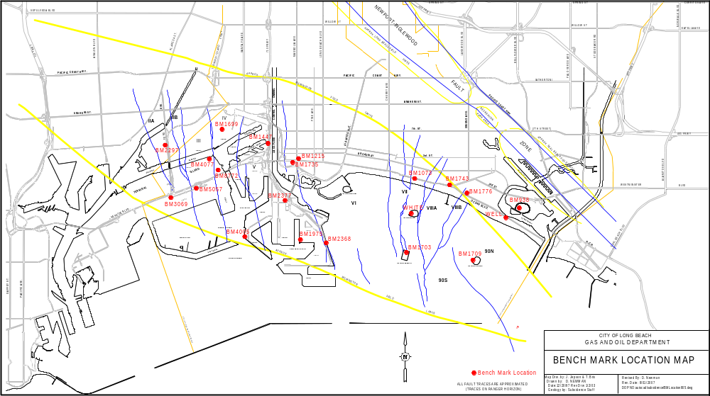

Figure 3



