AGENDA ITEM No. 4
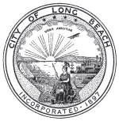

CITY OF LONG BEACH
Office of Sustainability
333 West Ocean Blvd., 13th Floor Long Beach, CA 90802 (562) 570-6396 FAX (562) 570-6583

September 23, 2010

CHAIR AND SUSTAINABLE CITY COMMISSIONERS
City of Long Beach
California

RECOMMENDATION:

Recommendation to receive an update on Youth Green Workforce Development Programs.
Suggested Action: Approve recommendation.

DISCUSSION

The Office of Sustainability has an ongoing partnership with the Pacific Gateway Workforce Investment Network (PGWIN) to engage and train youth workers in entry-level urban greening activities. This item will serve as an update to the progress of these programs.

ENVIRONMENTAL IMPACT

Not applicable.

SOCIAL IMPACT

Not applicable.

ECONOMIC IMPACT

Not applicable.

Respectfully submitted,
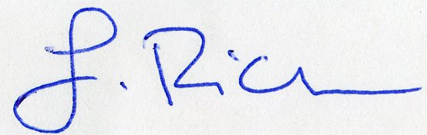
LARRY RICH
SUSTAINABILITY COORDINATOR

LR
P:\Sustainability\Sustainable City Commission\Mtg 9-23-10

