1
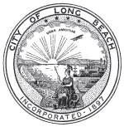

NOVEMBER 10, 2014

ITEM #1 - EXHIBIT B

LARGE ATTACHMENT

PLEASE CONTACT MARK HUNGERFORD TO OBTAIN A COPY

THE CITY OF LONG BEACH PLANNING BUREAU
CULTURAL HERITAGE COMMISSION
(562) 570-6194

